**Rohith Rajagopalan Ramesh Babu**

**1001518031**

[**2208-CSE-5382-001**](https://uta.instructure.com/courses/62497)

**Assignment 2: Shellshock**

**Task-1 :**

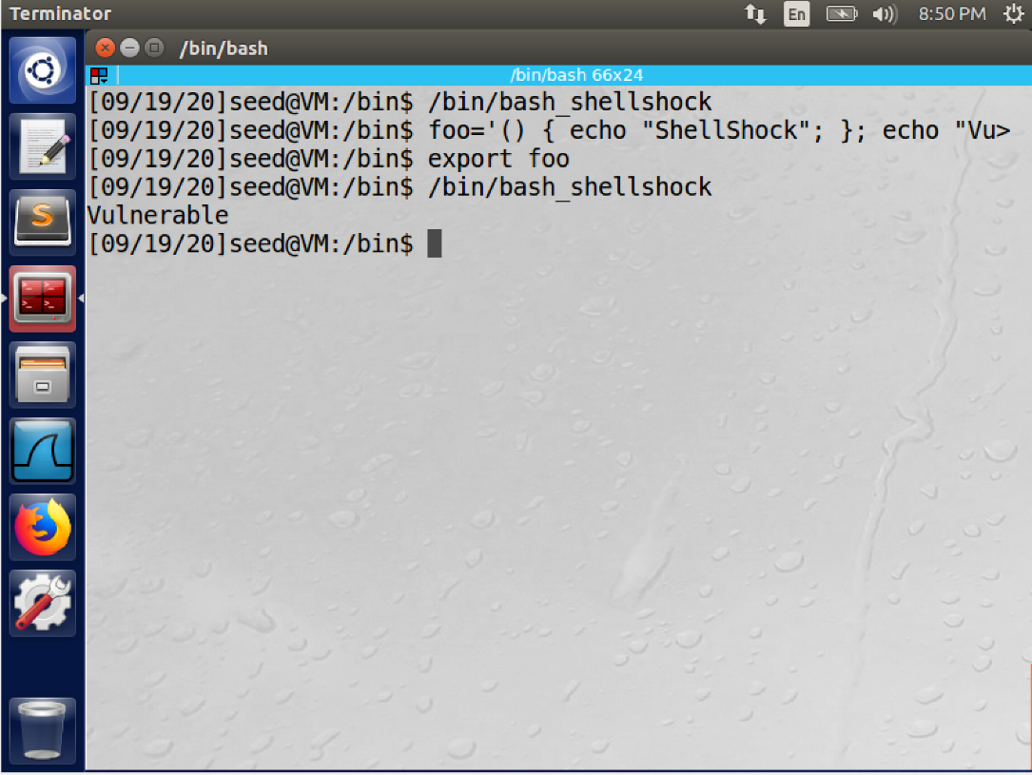

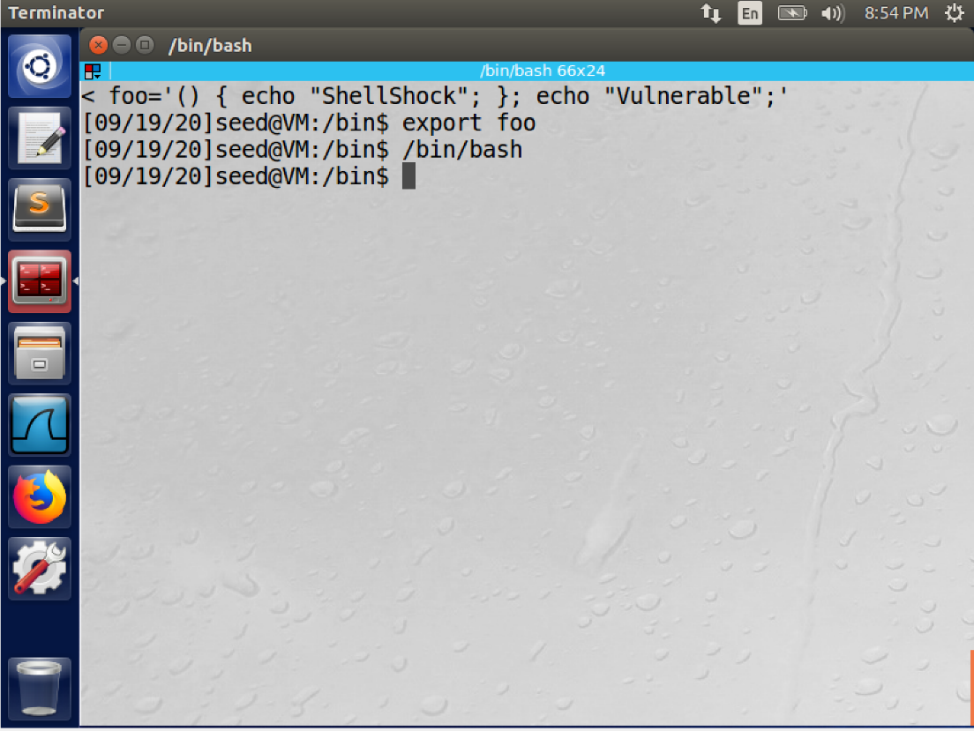

**Observation**:

* Fig 1 is the result of execution using the vulnerable bash, bash_shellshock , From the above image we can see that the bash_shellshock is not secure. The display of the random command “Vulnerable” proves this statement.
* Fig 2 is the result of execution using the patched bash, we can see that the random command “Vulnerable” is not displayed here hence we can conclude that this version of bash is secure.

Task-2:

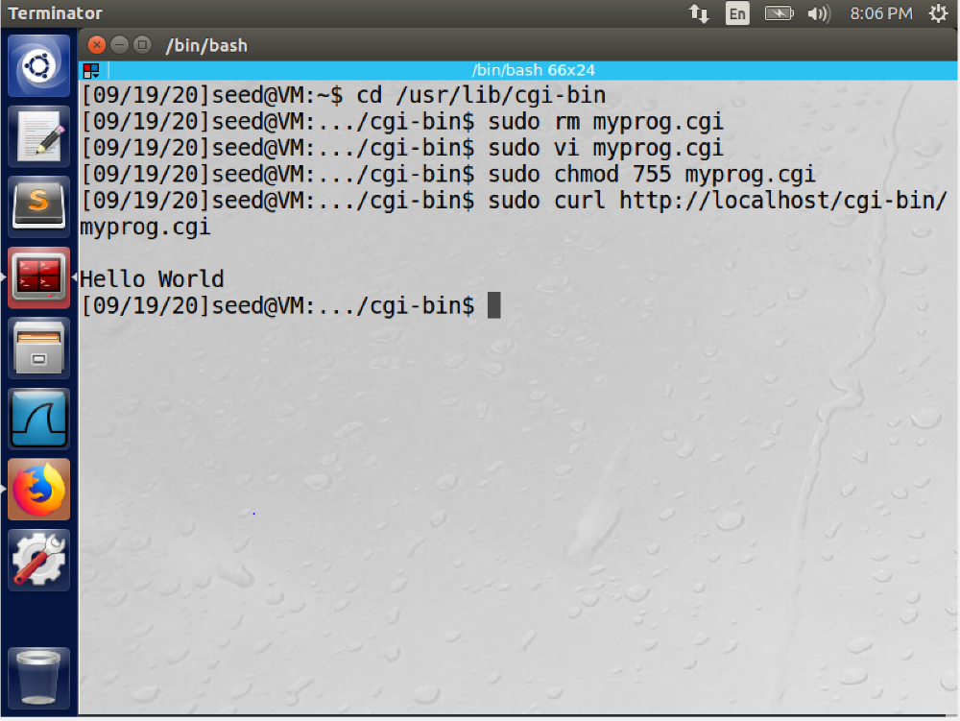

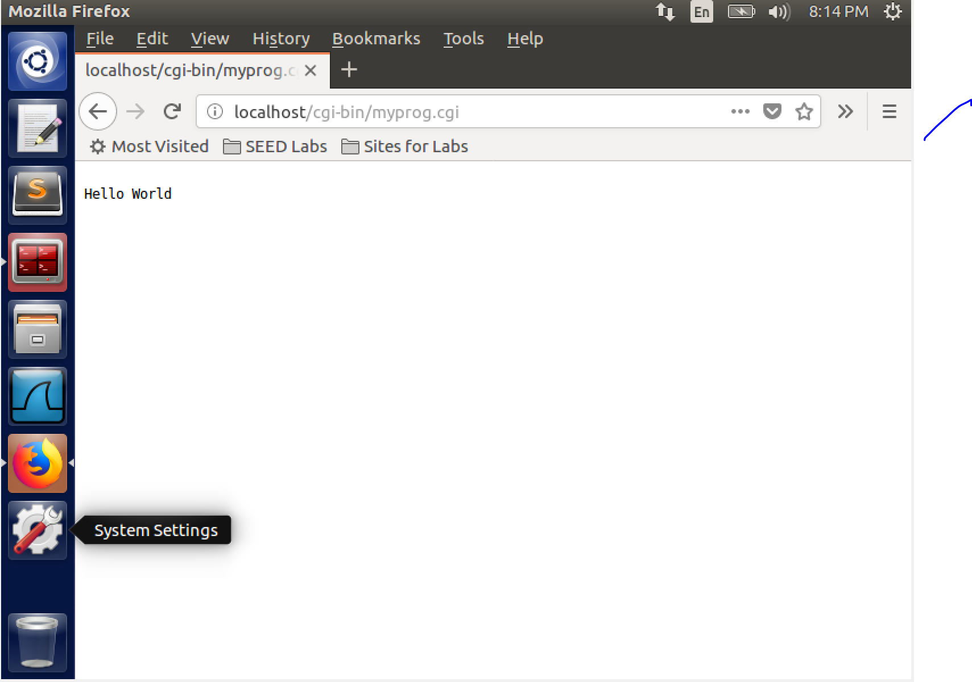

**Observation:**

* From the above it is clear that we can access to the CGI file by executing the curl command and following the directions of the lab manual.

**Task3:**

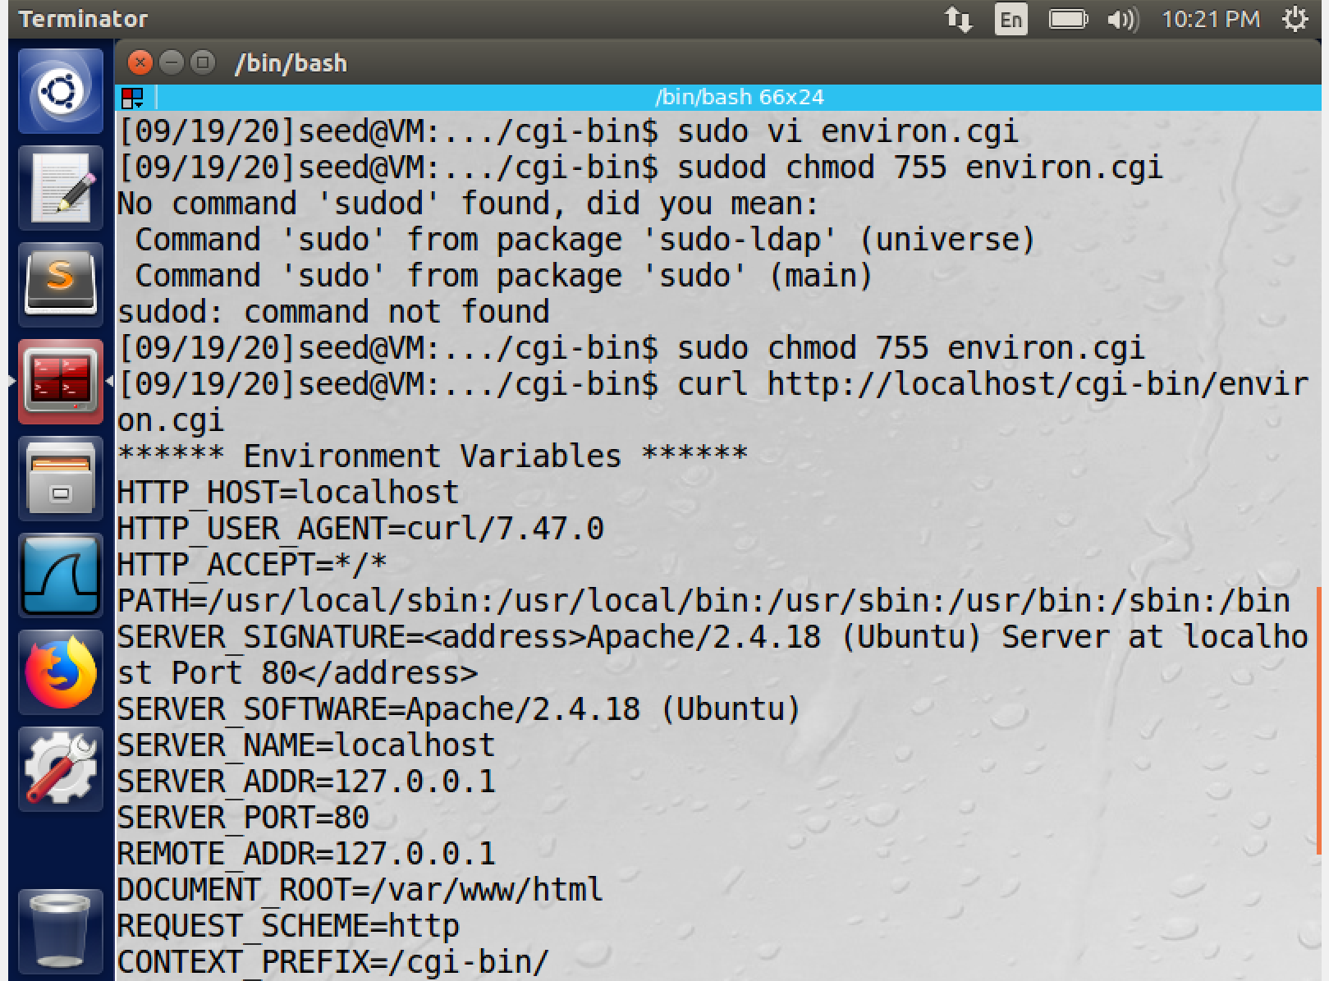

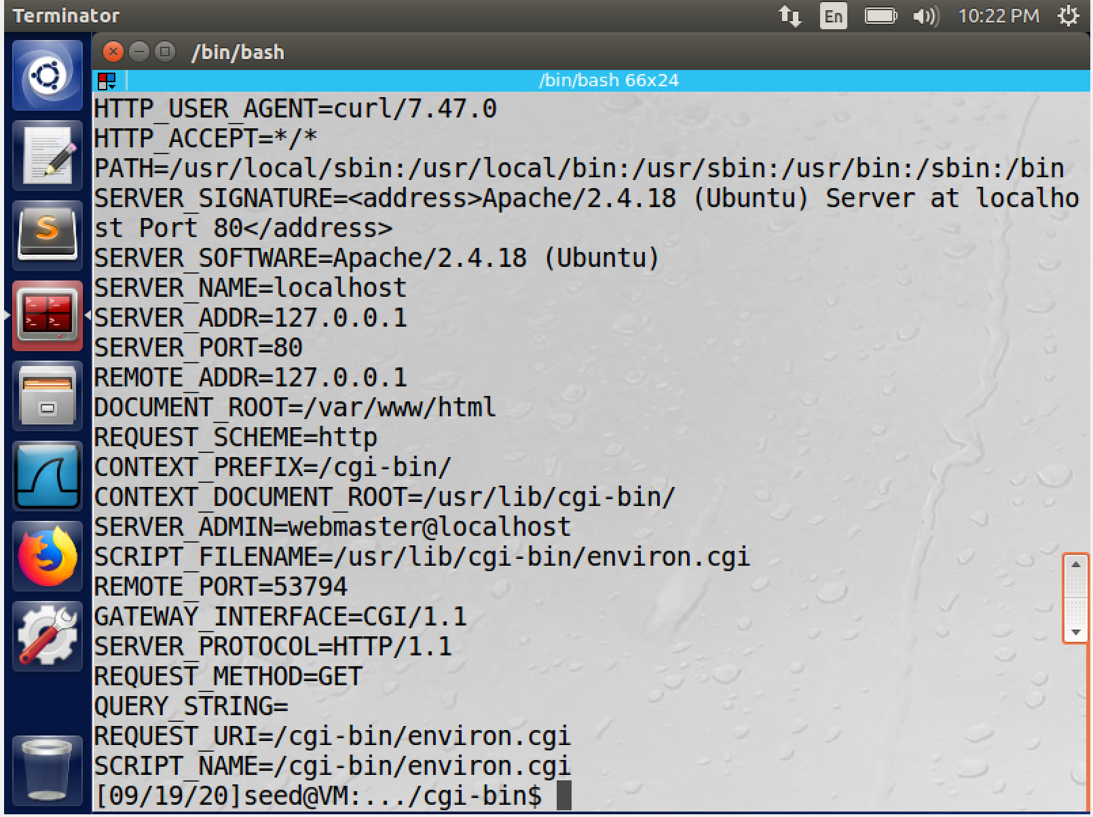

**Observation:**

* The program starts with ‘#!/bin/bash_shellshock’, this creates a way for the exec() function to actually execute /bin/bash_shellshock bash, which then runs the shell script that allows us to exploit the server as Apache creates a child process, it provides the environment variables.

Task 4:

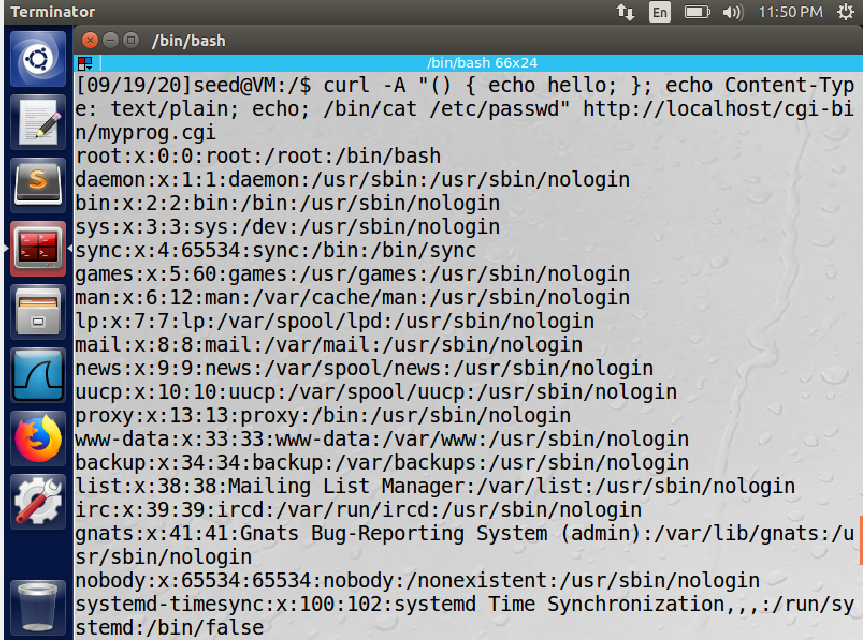

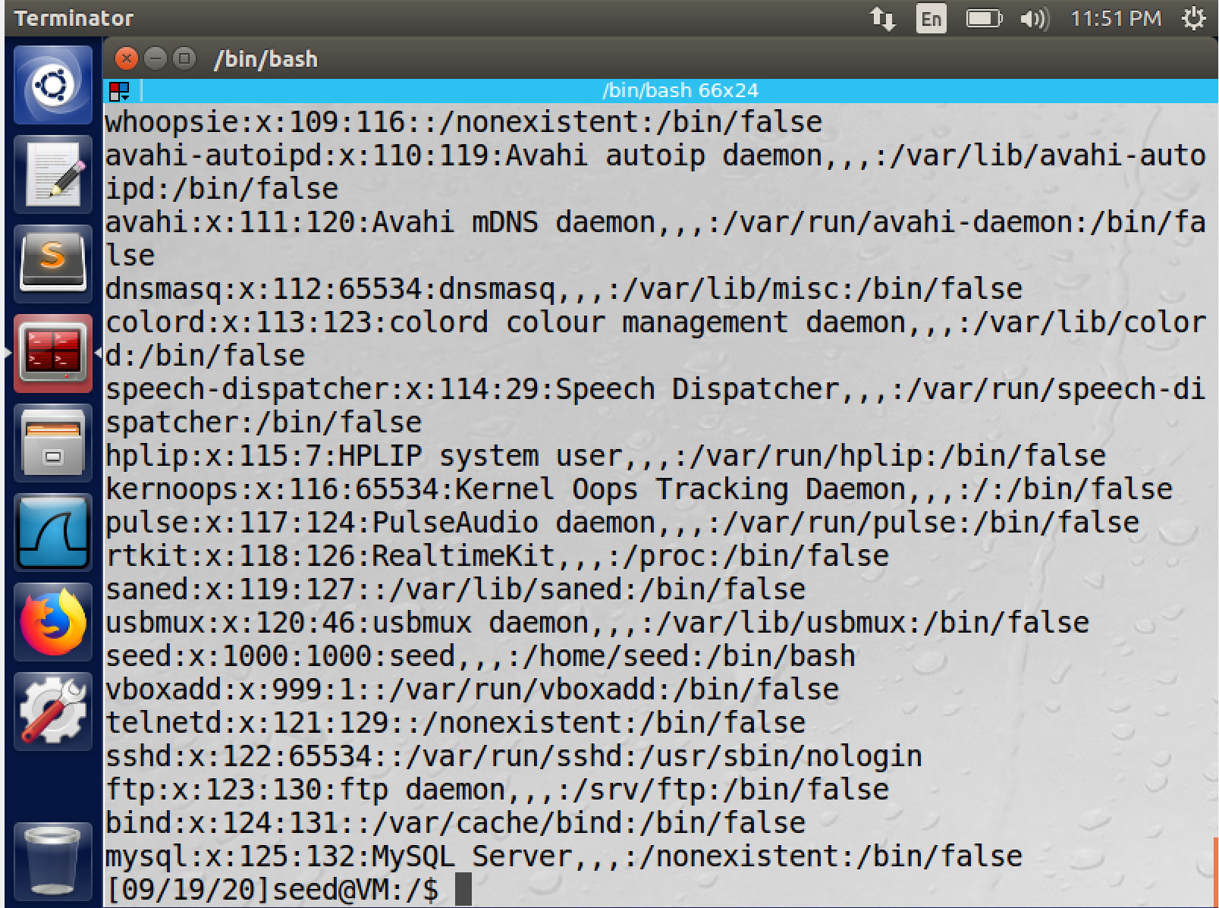

**Observation:**

* The above execution, the command enables access to the passwd file which is owned by the ‘root’.
* It can also be seen that since the shadow file is not owned by root the access is denied and the attack is unable to extract the data from the shadow file

**Task 5 :**

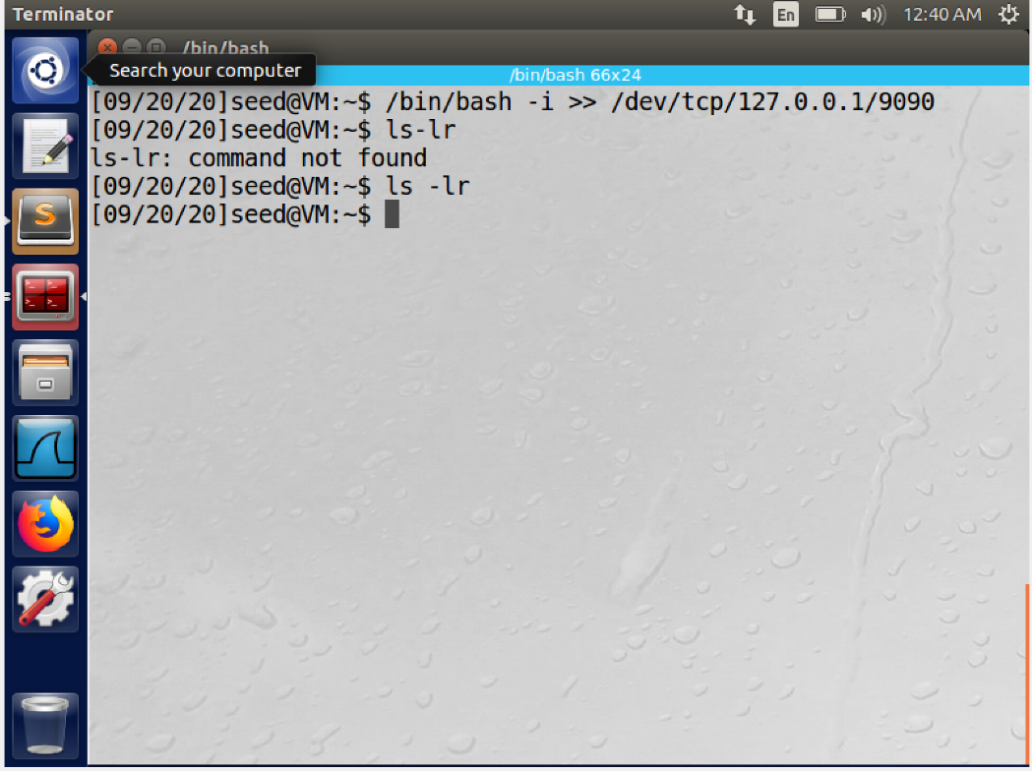

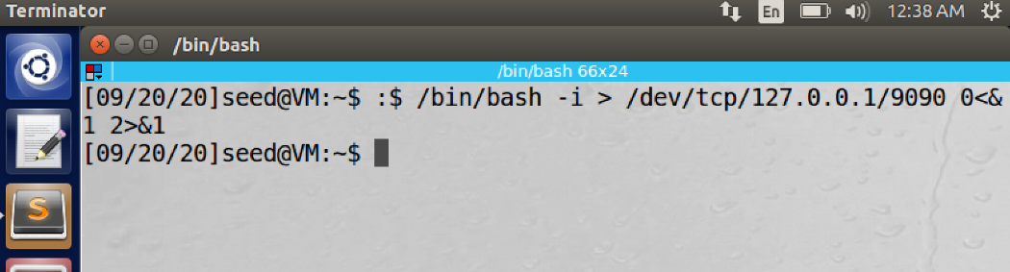

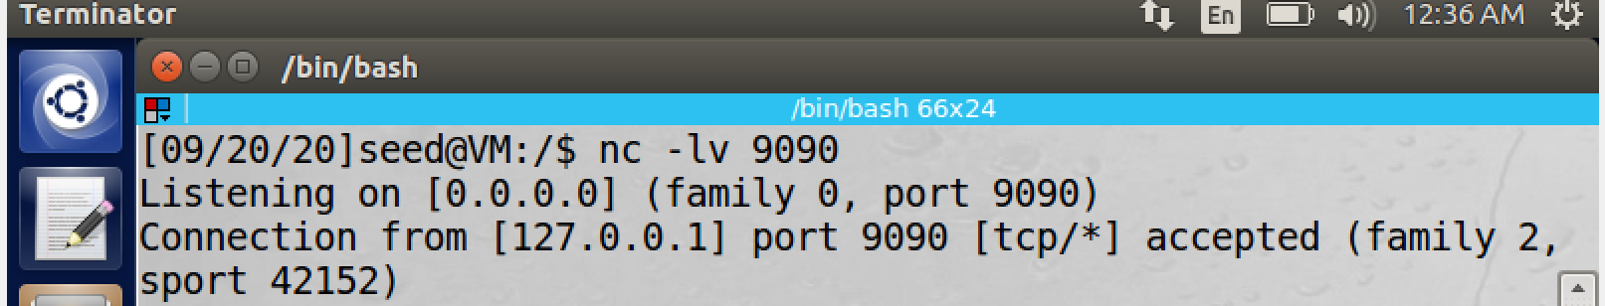

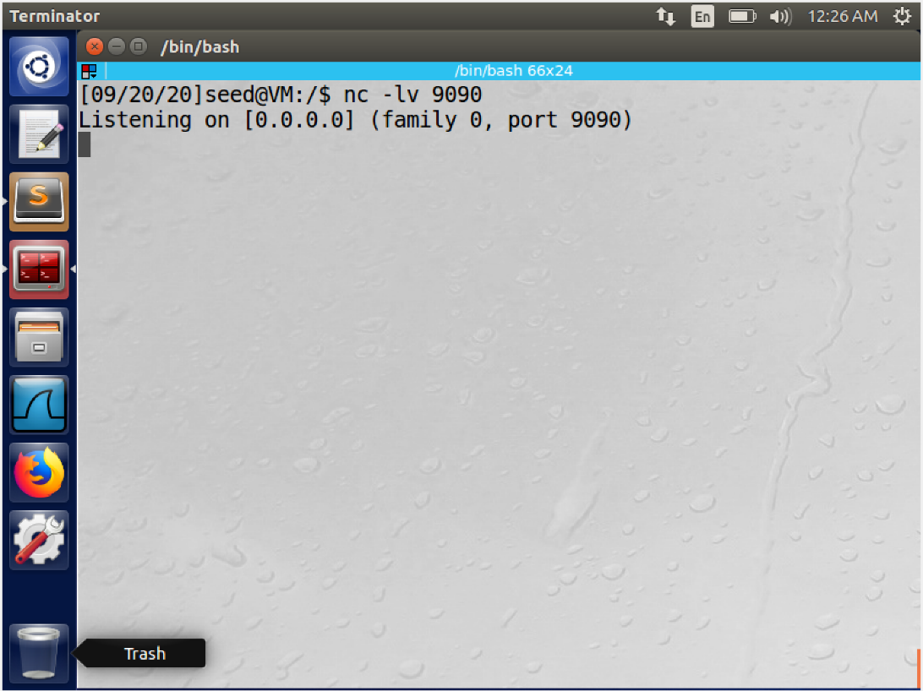

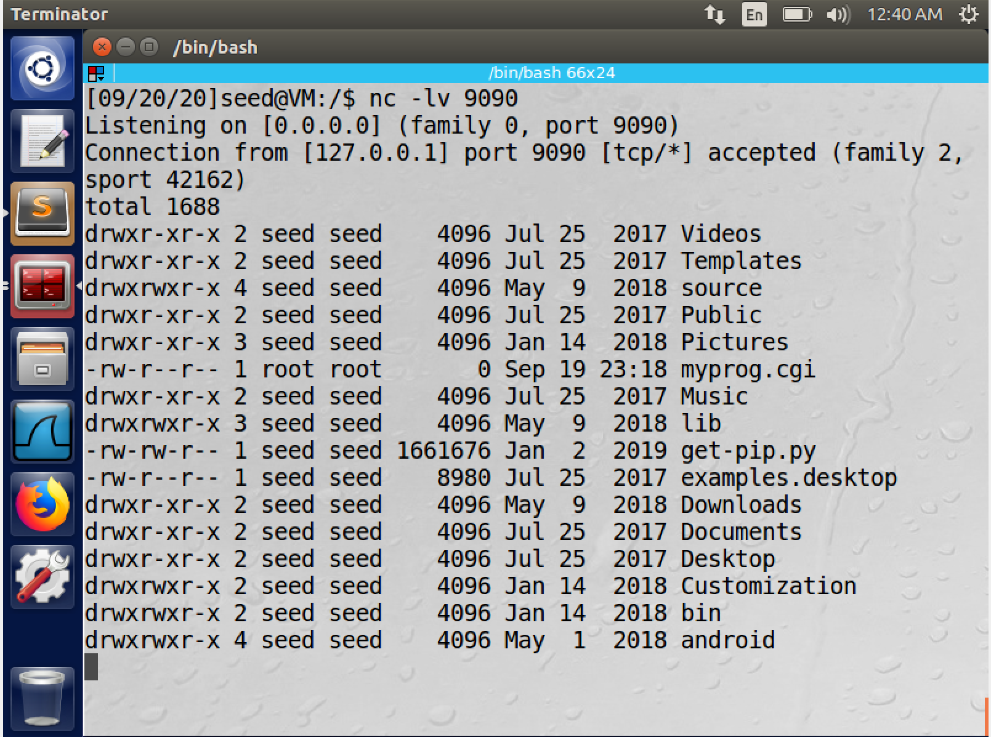

**Observation:**

* In the above experiment we use the command ls –lr , the output variables are displayed in the other terminal. This is because of a concept called “Broken Bash”. This demonstrates, how reverse shell is working.

**Task 6:**

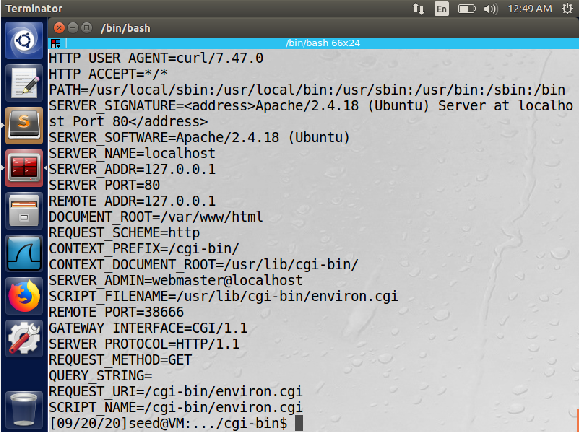

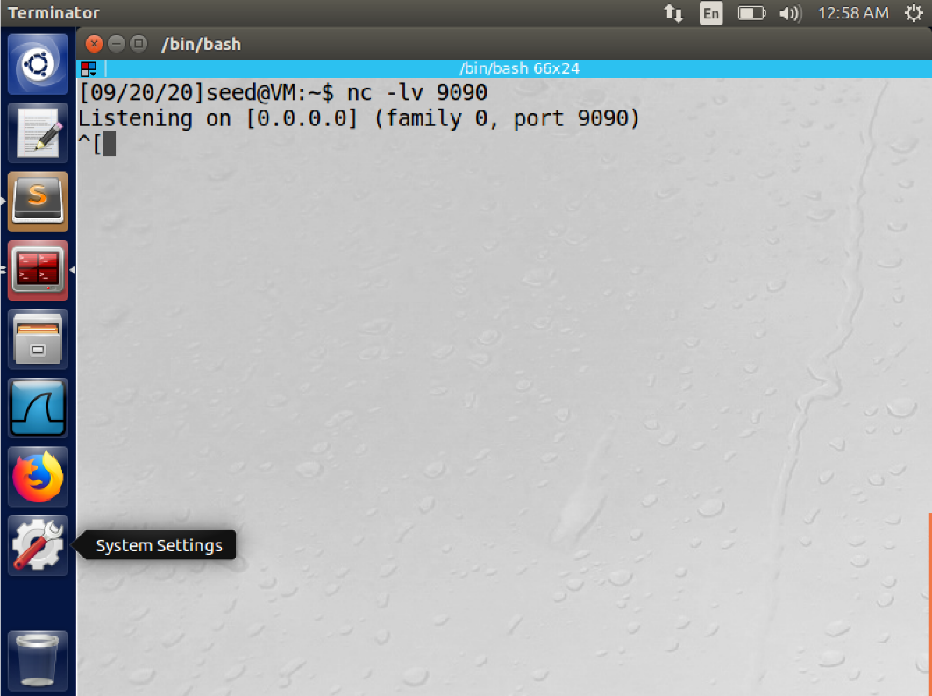

**Observation:**

**When task 3 is implemented with /bin/bash-**

* The machine is resistant to the curl command, making it secure.

**When task 5 is implemented with /bin/bash:**

* We can see that the reverse shell cannot be accessed while using the /bin/bash as counter measures have been implemented to prevent shellshock vulnerability, connection is kept live but the machine cannot be reached by the commands executed in /bin/bash.